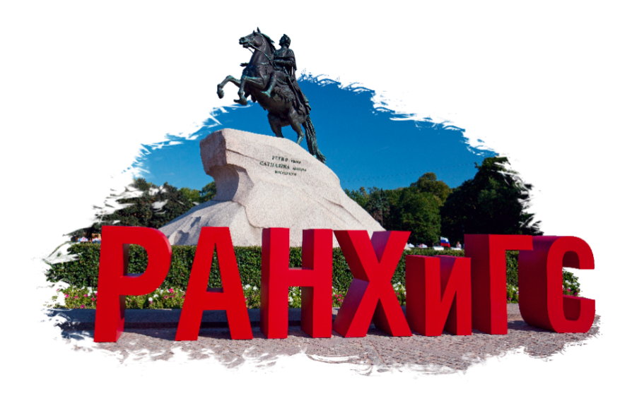

RANEPA SAINT PETERSBURG INVITATION

International Summer School "Law and Administration"

June 3-4, 2024

Dear colleagues and partners,
We invite the students of your university to participate in a distance format in a small project International Summer School "Law and Administration"
on June 3 and 4, 2024, which is organized by Faculty of Law, Faculty of State and Municipal administration and Sector for International Exchanges and Cooperation of North-West Institute of Management RANEPA. The teachers from Faculty of Law and Faculty of State and Municipal administration of RANEPA SAINT PETERSBURG will give lectures on different aspects of International law and general issues of State and Municipal administration.

Event program

June 3, 2024

Time | 12:00-14:20 (Moscow time)
Platform | Online, Yandex.Telemost (information is being confirmed)
Language | English
Moderator | Elizaveta Prokopenko, Leading Specialist Center for Cooperation with Partners in the Asia-Pacific Region, ICD RANEPA SAINT PETERSBURG
Participants |  |  | Anatoly  Likhtin | Dean of Faculty of State and Municipal administration, RANEPA SAINT PETERSBURG
Participants |  |  | Sergey Sergevnin | Dean of Faculty of Law, RANEPA SAINT PETERSBURG
Participants |  |  | Karina  Tirabian | Associate Professor of the Department of State and Municipal administration, RANEPA SAINT PETERSBURG
Participants |  |  | Georgy Alekseev | Associate Professor of the Department of International and Humanitarian Law, RANEPA SAINT PETERSBURG
Participants |  |  | Elizaveta Prokopenko | Leading Specialist Center for Cooperation with Partners in the Asia-Pacific Region, ICD RANEPA SAINT PETERSBURG
Content | 12:00-12:10 | Welcome speech of the Faculty of Law | Sergey  Sergevnin | Dean of Faculty of Law, RANEPA SAINT PETERSBURG
Content | 12:10-12:20 | Welcome speech of the Faculty of State and Municipal administration | Anatoly  Likhtin | Dean of Faculty of State and Municipal administration, RANEPA SAINT PETERSBURG
Content | 12:20-13:20 | Lecture: “Phenomenology of digital assets and digital rights” | Georgy Alekseev | Associate Professor of the Department of International and Humanitarian Law, RANEPA SAINT PETERSBURG
Content | 13:20-14:20 | Lecture: “Extremism and terrorism as a threat to the country's national security” | Karina  Tirabian | Associate Professor of the Department of State and Municipal administration, RANEPA SAINT PETERSBURG

June 4, 2024

Time | 12:00-14:10 (Moscow time)
Platform | Online, Yandex.Telemost (information is being confirmed)
Language | English
Moderator | Elizaveta Prokopenko, Leading Specialist Center for Cooperation with Partners in the Asia-Pacific Region, ICD RANEPA SAINT PETERSBURG
 |  |  | Alexander Lebedev | Associate Professor of the Department of International and Humanitarian Law, RANEPA SAINT PETERSBURG
 |  |  | Almira  Muftahova | Lecturer of the Department of State and Municipal administration, RANEPA SAINT PETERSBURG
 |  |  | Elizaveta Prokopenko | Specialist of Sector for International Exchanges and Cooperation, ICD RANEPA SAINT PETERSBURG
Content | 12:00-13:00 | Lecture: “Features of demographic and migration processes in the modern world” | Almira  Muftahova | Lecturer of the Department of State and Municipal administration, RANEPA SAINT PETERSBURG
Content | 13:00-14:00 | Lecture: “Problems of cross-border e-commerce legal regulation” | Alexander Lebedev | Associate Professor of the Department of International and Humanitarian Law, RANEPA SAINT PETERSBURG
Content | 14:00-14:10 | Closing of Summer School | Elizaveta Prokopenko | Leading Specialist Center for Cooperation with Partners in the Asia-Pacific Region, ICD RANEPA SAINT PETERSBURG

